Please complete the following and return to The Creative Canvas with your $25 deposit.
Child’s Name: ________________________________ Occasion ____________________ Age ________
Parent’s Name _____________________________________
Address : _____________________________________City, State & Zip _________________________
Phone: ______________________________ Email: ____________________________________
Event Date: _________________ Time: _________________ Approx # of guests ___________

Two hours- includes activity & use of the party area. Parties are available at the following times:
Monday-Thursday Time Varies due to class activities. Please call for availability.
Fridays 6-8pm *There is an additional $80 fee for a Friday night party and must be booked at least 4 weeks in advance.
Saturdays 10-Noon, 12:30-2:30, & 3:00-5:00 Sundays 1:00-3:00, 3:30-5:30
___Basic Party- $80 for up to the first 8 artists. Each add’l artist is $8. Paint on 8x10 canvas or jewelry making.
___Budding Artist Party- $135 for up to the first 8 artists. Each additional artist is $14. Paint on 11x14 canvas.

Total party time 2 hours. You are responsible for decorations, table wear etc. (see our upgrades below for full service options) & trash clean up. You may come in 15 minutes before your scheduled time to set up. Clean up must be completed by the end of your party time.
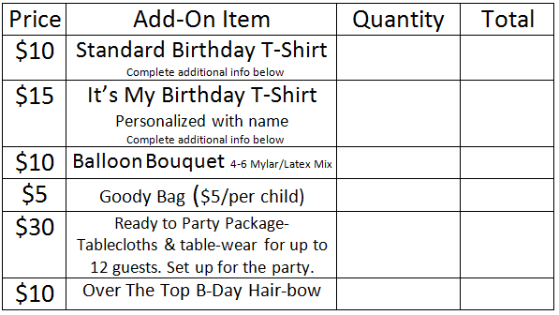
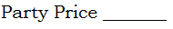
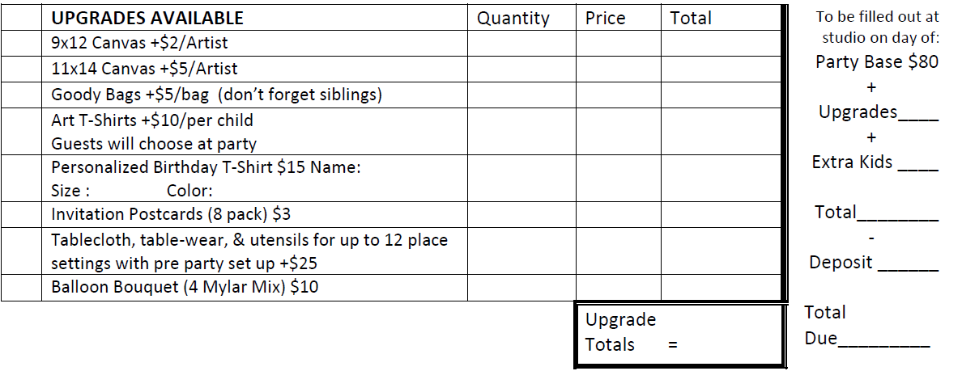
Guest Party Shirts (Youth) S____ M ____ L ____ XL _____
“It’s My Birthday” Shirt: Size _______ Name ______________________________ Color _______________________

A $25 deposit (plus shirt fee, if any) is due at time of booking.
You will pay the balance due including any additional artists the day of the party. Any changes to the party MUST be made 7 days in advance. Deposits will NOT be returned or transferred for canceled parties.
Please Note-
You are responsible for the guests at your party. You will be charged for any merchandise that is damaged or broken by your guests during the course of your event. We are both an art studio and a retail store- please remind guests that food is NOT allowed out of the party area and there is no running or rough housing allowed in the studio.
Also, for safety reasons, please do NOT give out un-inflated balloons to party guests.
Thank you!

Signature ___________________________________________ Date _________________________________
Return to: The Creative Canvas 982 N. Main Plaza Dr. Cornelia, GA 30531 706-776-1022

