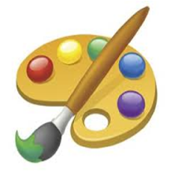
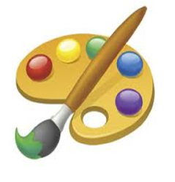
The Creative Canvas
Birthdays Are Better Here!
Located at: 982 N. Main Plaza Dr., Cornelia, GA

Packages starting at just $80!
Each 2 hour party includes an hour of instruction, materials, & an hour use of the party area.

Basic Package:
$80 for first 8 painters + $8 each additional artist. 8x10 canvas.

Budding Artist Package:
$135 for first 8 painters + $14 each additional artist. 11x14 canvas.

3 Hour Special:
$250 for first 8 painters + $25 each additional artist. 16x20 canvas.
Great for Baby Showers & Bridal Parties!
Available Friday & Saturday Nights, and Sunday Afternoons.

Make Your Event Even More Fun!
Ask about our affordable add-ons!
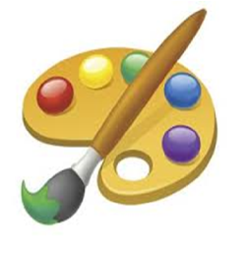
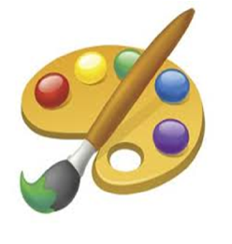
Custom Party T-Shirts, Goody Bags, Decorations, Balloons, & More!

Check Us Out Online!
www.TheCreativeCanvas.net
706-776-1022 facebook.com/TheCreativeCanvas

